**My Interpretation**

**RQ1)**

**CCMv(i) ~ TCMv(i+1) – TCMv(i)**

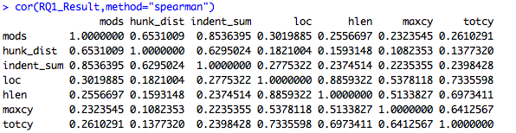

**RQ2)**

**TCMv(i+1) ~ ∑0-i CCMv(i) n=1000**

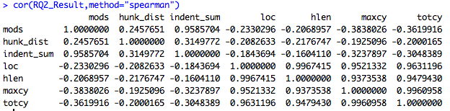

**RQ3)**

**The traditional measures calculated on only the files that had changed, compared to CCM at last 1000 changed.**

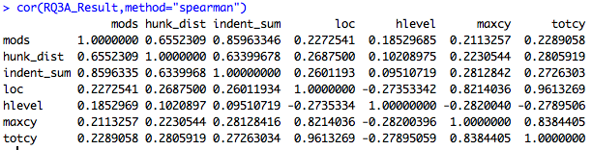

**The traditional measures calculated on only the files that had changed, compared to CCM**

